**Hridai Nath Wanchoo**

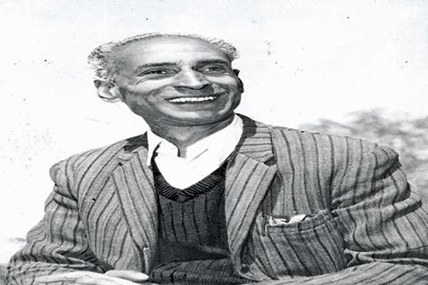

**About:** Hridai Nath Wanchoo was born in a family of academicians and technocrats on 24th May 1925 at Maliyar, Habba Kadal. His father Keshav Nath Wanchoo was a government employee in judicial department and mother Leelavati was a house maker. He received his primary education from Ganesh Ghat School and later passed his matriculation from S.P. School, Fatehkadal. Mr. Wanchoo joined S. P College and passed his degree from Lahore University. During his college career, he was actively involved in student politics and also associated with various organizations fighting for social equality, rights of downtrodden, right to health and sanitation. He also actively participated in “QUIT KASHMIR MOVEMENT” which was that time headed by J&K National Conference founder Sheikh Muhammad Abdullah. Because of his active involvement he got arrested and was jailed for around a year. He was put in detention at various jails of Jammu and Kashmir from time to time.

**Murdered on:** December 5, 1992 at Balgarden.

**Attack details:** My grandfather lost his life because he was very emotional whenever plight of downtrodden was involved. On the fateful day, he was told that a Safai Karamchari family is in shambles and looking for you as their son has been taken by security forces. Without waiting a second, even ignoring his severe joint pain he went with two guys in auto and third guy following on scooter to Karan nagar where he was assassinated.

**Reason to him target:** Same day whole country was up in flames because of Babri Masjid demolition but in Kashmir we had majority community by our side sharing grief with us and Kashmir was closed for three days in memory of my grandfather. This call was not given by any organisation but voluntarily by people of Kashmir. My grandfather lost his life because he was very emotional whenever plight of downtrodden was involved. On the fateful day, he was told that a Safai Karamchari family is in shambles and looking for you as their son has been taken by security forces. Without waiting a second, even ignoring his severe joint pain he went with two guys in auto and third guy following on scooter to Karan nagar where he was assassinated.

.**Occupation** Hridai Nath Wanchoo, he was a social activist who selflessly worked for the downtrodden, founder of Human Rights movement, pioneer of workers movement and trade unions in the state.

**URL** **:** <https://www.greaterkashmir.com/news/opinion/remembering-wanchoo/>